

Structural Design

(Inside View)

**Vertical corrugation**

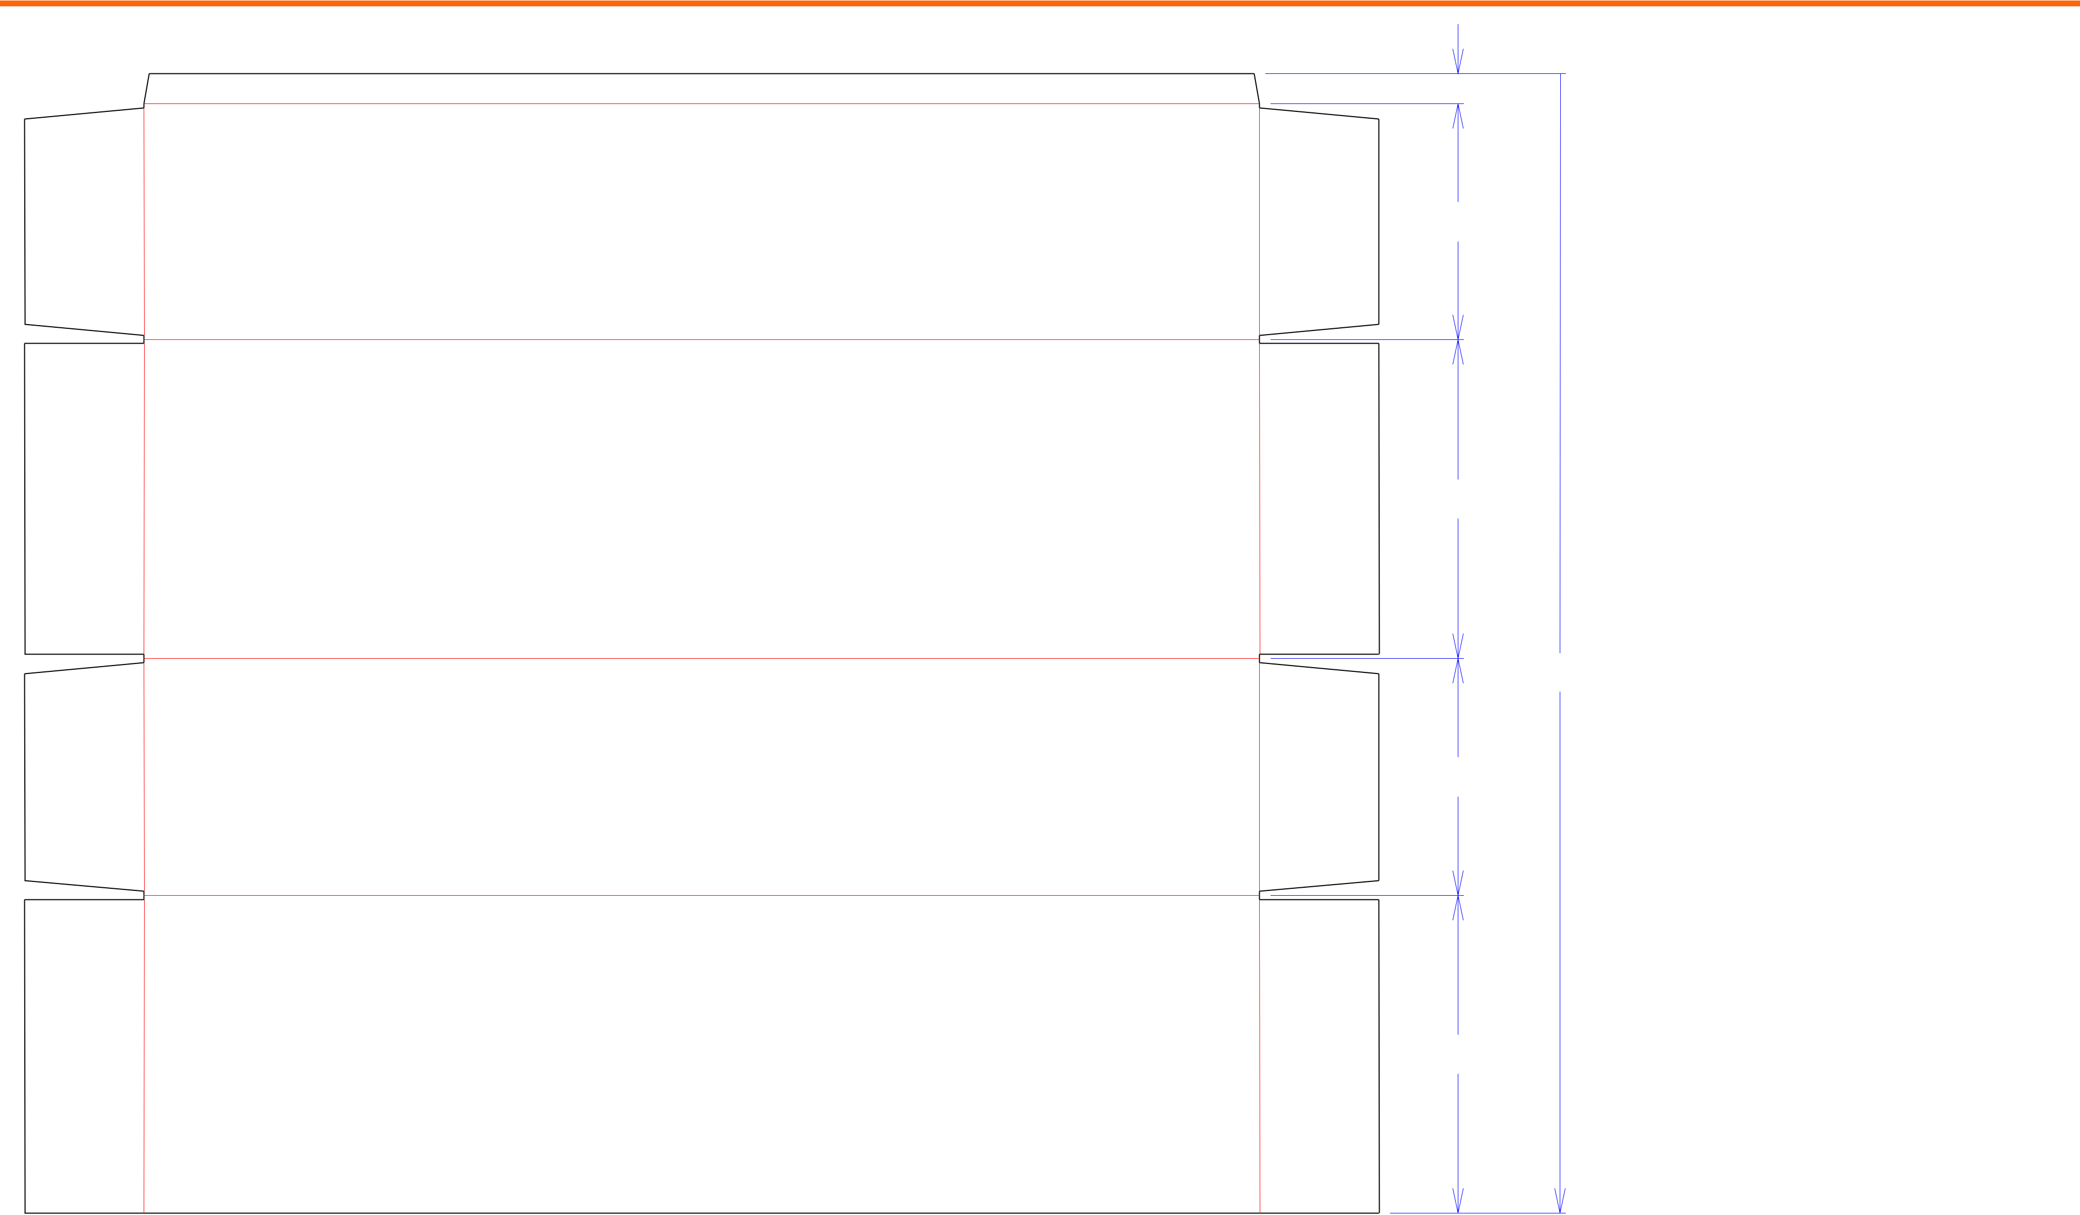

Design#:

13*/*8  **160923-03**

Customer:

**DeMet's Candy**

103*/*4

Description:

**Shipper -40ct 7.5oz Flipz Display**

|  |  |  |  |
| --- | --- | --- | --- |
| 149*/*16 |  | **SINGLE-OUT DRAWING** |  |
| Qty/Unit: | **1 Per Display** |  |
|  |  |  |
|  | Style: | **RSC** |  |

Board: **44CK**

Combination: **42 - 36M - 42**

52 I.D. : **14+3/8 x 10+5/8 x 50+1/2**

1013*/*16

141*/*2

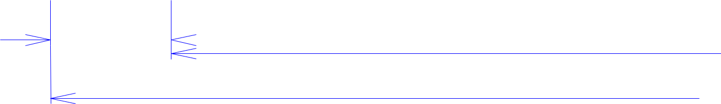

|  |  |  |  |  |  |  |  |  |  |  |  |  |  |  |  |  |  |  |
| --- | --- | --- | --- | --- | --- | --- | --- | --- | --- | --- | --- | --- | --- | --- | --- | --- | --- | --- |
| 57*/*16 |  |  |  | 507*/*8 |  |  |  |  |  |  |  |  | 57*/*16 | | | |  |  |
|  |  |  |  |  |  |  |  |  |  |  |  |
|  |  |  |  |  |  |  |  |  |  |  |
|  |  |  |  | 613*/*4 | Half Knife Cut | Tear Tape | | | | | | |  |  |  |  | Perforation |  |
|  |  |  |  |  |  |  |  |  |
| Cut | | Crease | Crease with Matrix | Cut Crease |  |  |  |  |  |
|  |  |  |  |  |  |  |  |  |  |  |  |  |  |  |  |  |  |  |



Area of Blank - Waste : **22.02 sq. ft.**

Waste on Blank : **1.26%**

Finished Piece Weight: **3.02 lbs./1371.42g**

Over-all Blank: **52 x 613/4**

Notes:

**cross corrugated - Holds 1 Complete Display / Display Ships On It's Back**

Revision Info: **[0] 07/26/2016**

Designer: **Alan Groff**

Designright and Copyright of DS Smith Corrugated Packaging Ltd. This technical Specification is subject to Manufacturing tolerances. Drawing dimensions shown are crease to crease. Date printed: 07/03/2018